TITLE OF THE THESIS
NAME SURNAME
ÖZYEĞİN UNIVERSITY
MONTH, YEAR
TITLE OF THE THESIS

by
Name Surname
Thesis
Submitted in Partial Fulfillment of the
Requirements for the Degree of
Master of Science
in
Design, Technology, and Society
Advisor: Full Title Name Surname
Co-advisor: Full Title Name Surname
Graduate School of Social Sciences
Özyeğin University
İstanbul
Month, Year
TITLE OF THE THESIS
Approved by:

Full Title Name Surname, Advisor
Department of ……
Özyeğin University
Full Title Name Surname
Department of ………
Özyeğin University
Full Title Name Surname  Department of ……..  ……. University | Approval Date:

To …
(The dedication page is optional. If there is a dedication statement, it should be written in italic and Times New Roman 14 pt. and centered. The dedication statement should be short, preferably not more than a line (a maximum of two lines). If the statement is two lines, it should be double-spaced and justified. Acknowledgments should be given on the acknowledgments page, not on the dedication page.)

DECLARATION OF ORIGINALITY
I hereby declare that I am the sole author of this thesis and that this is the true copy of my thesis, including the final revisions, approved by my thesis committee. All data and information have been obtained, produced, and presented in accordance with the rules of research ethics and principles of academic honesty. As required by these rules, to the best of my knowledge, I have acknowledged ideas, thoughts, and any copyrighted material in accordance with the standard referencing rules. I certify that any part of this thesis has not been submitted for a degree or diploma in another educational institution.
Signature
Name Surname

ABSTRACT
All main titles, including the ABSTRACT, must be bold in Times New Roman, 12 pt. From this page on, the main text should be in Times New Roman, 12 pt., double-spaced throughout the manuscript. Throughout the manuscript, margins of all vertical pages are 3.5 cm from the left, 2.5 cm from the right, 3.5 cm from the top, and 2.5 cm from the bottom; the margins of the horizontal pages should be 2.5 cm from the left, 3.5 cm from the right, 3.5 cm from the top, and 2.5 cm from the bottom. This document is formatted as it is required to guide you. The abstract must be written in a single paragraph (non-indented) like this. An abstract concisely states the study's aim, method, results, and conclusion. On the abstract page, a maximum of five keywords must be written at the end of the page (see below). Keywords are written in lowercase and separated with commas. If a keyword is a proper word, its first letter should be capitalized. The first keyword must be capitalized. Do not put punctuation at the end of the keywords line.
Keywords: Keyword1, keyword2, keyword3, keyword4, keyword5

ÖZET
This is where the Turkish version of the abstract should be placed. The same formatting principles apply to the Turkish version as those given for the English abstract.
Anahtar Kelimeler: Kelime1, kelime2, kelime3, kelime4, kelime5

ACKNOWLEDGMENTS
The Acknowledgment page is optional. However, if there is an organization that has funded the thesis work, the permissions obtained to use data that is not open to the public, permissions to use copyrighted material, and the permissions to use any content within the scope of the Personal Data Protection Law should be stated on the Acknowledgments page. In such cases, it is mandatory to include an Acknowledgment page that acknowledges the support and permissions obtained. The acknowledgment page can include multiple paragraphs. The first lines of the paragraphs should be indented with 1 tab (1.25 cm).

TABLE OF CONTENTS
DECLARATION OF ORIGINALITY iv
ABSTRACT v
ÖZET vi
ACKNOWLEDGMENTS vii
LIST OF TABLES ix
LIST OF FIGURES x
LIST OF ACRONYMS AND ABBREVIATIONS xi
LIST OF SYMBOLS xii
1. INTRODUCTION 1
1.1 Literature Review 2
1.1.1 Primary Concept/Theory 2
1.1.1.1 Secondary Concept/Theory 2
1.1.1.1.1 More on the Secondary Concept 2
1.2 Aims and Objectives 2
2. METHOD 3
2.1 Research Phases 3
2.2 Theory 3
3. CASE STUDY 4
3.1 Data Gathering and Survey 4
3.2. Preliminary Results 5
4. ANALYSIS 7
4.1 Qualitative Analysis 7
4.2 Quantitative Analysis 7
5. CONCLUSION 8
REFERENCES 9
APPENDICES 10
APPENDIX A. THE TITLE 11
APPENDIX B. THE TITLE 12

LIST OF TABLES
Table 3.1 The Title of the Table 5

LIST OF FIGURES
Figure 3.1 The Caption of the Figure 6

LIST OF ACRONYMS AND ABBREVIATIONS
HVAC: Heating, Ventilating, and Air Conditioning
IMR: Institutional Mode of Representation
ANOVA: Analysis of Variance
HCI: Human Computer Interaction
DES: Design
VR: Virtual Reality

LIST OF SYMBOLS
df: Degrees of freedom
F: F distribution
X̄: Arithmetic average
κ (kappa): Cohen’s measure of agreement corrected for chance agreement
σ (sigma): Population standard deviation
Σ (capital sigma): Population variance-covariance matrix
Σ (capital sigma): Population variance-covariance matrix

1. INTRODUCTION
Each chapter must begin on a new page. The first chapter is always titled Introduction. The chapters are numbered in Arabic numerals, and all main titles are capitalized and bold. The main text, including section headings and subheadings, is all 12 pt. The text after section headings begins as a new paragraph.
For the preliminary pages, use small Roman numerals (i, ii, iii, iv, v, vi, vii, and the like) as in this document. The Title page, the Approval page, and the dedication page (if any) do not have page numbers, but are counted as i, ii, and iii, respectively. Explicit page numbering begins with page number iv on the Declaration of Originality page. If there is no dedication page (which is optional), numbering begins on the Declaration of Originality page, starting with iii. Use Arabic numerals beginning with "1" on the first page of the main text (i.e., the first page of the Introduction) and continue consecutively until the end, including the References and Appendices. It is already done in this document by page numbering.
There is no extra spacing after a paragraph or between paragraphs. All first lines of the paragraphs must be 1 tab (1,25 cm) indented. The main text should be justified throughout the manuscript. Each subsection of a chapter should follow the next without a page break. A new chapter, however, starts with a new page.
Every thesis should have an introduction. An introduction explains the purpose of the study, includes a section on the review of the literature, which delineates theories and empirical studies that are used to frame the research purpose and questions, and an explicit statement of the research questions and hypotheses of the thesis. A chapter has subsections. Level 1 headings are the chapter headings. They are all centered in uppercase and centered (e.g., 1. INTRODUCTION). There is a 12 pt. space after the heading.

1.1 Literature Review
Level 2 headings should be 12 pt., left-aligned, bold, title case (first letters of each word are capitalized and the other letters are small (e.g., 1.1 Literature Review). In Level 2 headings, the text begins as a new paragraph like this (e.g., the first line is 1 tab indented).

1.1.1 Primary Concept/Theory
Level 3 headings should be 12 pt., bold italic, left-aligned, and title case (e.g., 1.1.1 Primary Concept). The text begins with a new paragraph, as shown here.

1.1.1.1 Secondary Concept/Theory
Level 4 headings should Level 4 headings should be 12 pt., 1 tab indented, left-aligned, bold (e.g., 1.1.1.1 Secondary Concept). The text begins with a new paragraph, as shown here.

1.1.1.1.1 More on the Secondary Concept
Level 5 headings should be 12 pt, 1 tab indented, left-aligned, bold, italic, title case (e.g., 1.1.1.1.1 More on the Secondary Concept). The text begins with a new paragraph, as shown here. According to the APA Publication Manual, 7th edition, the maximum number of heading levels is 5. Please limit your heading levels to 5.

1.2 Aims and Objectives

2. METHOD
Titles, categorizations, and divisions in this template are indicated as suggestions, with the exception of the Introduction, which is mandatory. Each student is expected to format these elements of the thesis according to his/her research design. Please review the Publications Manual of the American Psychological Association (APA), 7th edition, for additional formatting rules and guidelines.

2.1 Research Phases
In some studies, equations are presented to elucidate the type of analysis conducted. If equations are included, they should be presented on a separate line, centered, and italic as shown in the sample equation below. The number of an equation is given in parentheses on the right side of the equation. Equations should be numbered for each chapter as exemplified below and referred to in the text as Equation 2.1. Multiple equations or syntaxes can be given in an appendix or within the text.
$u_{0}+u_{x}+u_{xxx }= 0$ (2.1)

2.2 Theory

3. CASE STUDY
Titles, categorizations, and divisions in the current template are indicated as suggestions, except for the Introduction, which is mandatory. Each student is expected to format the thesis according to their research design. Please review the Publications Manual of the American Psychological Association (APA), 7th edition, for additional formatting rules and guidelines.

3.1 Data Gathering and Survey
In some cases, we may also include tables and figures in the literature review to visually represent theoretical models. Table 3.1 provides an example of the table format. Publications Manual of the American Psychological Association (APA) 7 provides a variety of sample tables and figures for different types of analysis. Please review the Manual for the table and figure format that is suitable for your analyses.
Table 3.1 provides an example of the table format. Publications Manual of the American Psychological Association (APA) 7 provides a variety of sample tables and figures for different types of analysis. Please refer to the Manual for the table and figure format that is suitable for your analyses.
Please note that illustrations such as photographs are designated as figures and should be given a number as a figure (e.g., Figure 3.1). If any material you use in tables, figures, and illustrations is copyrighted, make sure that you have written permission to use it in your work.
All tables should be placed within the text where their content is explained. Tables must be referenced in the text and numbered for each section (e.g., Table 1.1, Table 2.1, Table 3.1). Letter and symbol fonts within a table can be 12, 11, 10, 9, or 8 pt. Font size cannot be smaller than 8 pt. The font size should be consistent across the tables in a thesis. The table title should be written in Times New Roman 12 pt., double-spaced (if there is more than one line), justified, italic, and title case. There is no period at the end of the table title and the table number. The title of a table should be short, preferably one line.
Table 3.1 The Title of the Table
 | Total | Girls | Boys
 | n M (SD) | n M (SD) | n M (SD)
Age
Grade
SES
Note. A note to a table is optional. If there is going to be a note, it should be in Times New Roman,10 pt, italic, single-spaced, justified, sentence case, and ending with a period like this.
SES: Socioeconomic status.

3.2. Preliminary Results
A figure or a table should not begin right after a heading. There should be a text between a figure and a heading. All figures should be referenced in the text and numbered for each chapter. Please note that in the last version of the Publications Manual of APA 7, the caption of a figure is placed above the figure (see Figure 3.1). Letter and symbol fonts within a figure can be 12, 11, 10, 9, or 8 pt. Font size cannot be smaller than 8 pt. The font size should be consistent across the figures throughout the thesis. For sharpness and clarity of the figures and illustrations, the resolution should be 300 dots per inch (dpi). Figures, illustrations, and tables can be colored or black and white. If colored, they should be printed in color. For black and white figures, make sure that you use identifying markers for different elements (e.g., bars). The caption of a figure should be written in Times New Roman 12 pt., double-spaced (if there is more than one line), justified, italic, and title case. Please note that there is no period at the end of the caption and the figure number. A figure caption should be concise, ideally in a single line.
Figure 3.1 The Caption of the Figure
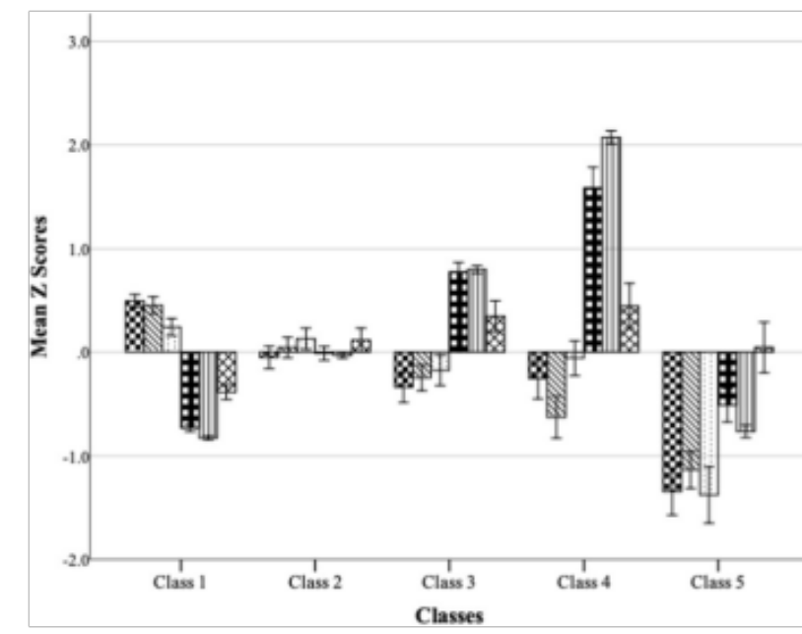
Note. A note to a figure is optional. If there is going to be a note, it should be in Times New Roman, 10 pt, italic. single-spaced, justified, sentence case, and ending with a period like this.

4. ANALYSIS
Titles, categorizations, and divisions are indicated as suggestions, except Introduction, which is mandatory. Each student is expected to format the thesis according to their research design. Please review the Publications Manual of the American Psychological Association (APA), 7th ed., for additional formatting rules and guidelines.

4.1 Qualitative Analysis

4.2 Quantitative Analysis

5. CONCLUSION
The conclusion section of a thesis summarizes and interprets the findings of the study in view of the theory and empirical work presented in the literature review section of the thesis. The writer should avoid introducing new content in the discussion unless the findings are unexpected in relation to the theory and empirical research on which the study design is based, and new information is necessary to interpret the unexpected findings.
The conclusion part does not include any statistical information unless it is crucial to mention these statistics. A discussion ends with addressing the limitations of the study and suggestions for future research, and one or two conclusion paragraphs summarizing the findings and the contribution to the literature.

REFERENCES
Julier, G. (2013). From design culture to design activism. Design and Culture, 5(3), 215-236. https://doi.org/10.2752/175470813X13638640370814
Lindsay, G. (Ed.) (2020). Contemporary museum architecture and design. Routledge.
Pegrum, M. (2009). From blogs to bombs: The future of electronic technologies in education. UWA Publishing.
Pickering. A. (2010). Material culture and the dance of agency. In D. Hicks and M.C. Beaudry (Eds.), The Oxford handbook of material culture studies (pp. 191- 209). Oxford University Press.

APPENDICES

APPENDIX A. THE TITLE
Ancillary material should be put in appendices, which appear right after the References. The appendices section should begin with a cover page, similar to the one on the previous page in this template. Each Appendix should be given on a separate page titled accordingly (e.g., APPENDIX A, APPENDIX B, etc.). The text in the appendices should be 1.5-spaced and justified. If appendices include a questionnaire, it should be single-spaced.

APPENDIX B. THE TITLE

Footnotes should be in Arabic numerals and numbered consecutively throughout the thesis/dissertation; Formatting: Times New Roman, 10 pt., single space.

